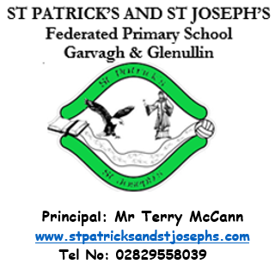
November 2023

Admission of Children
to Primary School

Children, who are four on or before 1 July 2024, are due to start school in September 2024.
Mary’s Meals  On December 6th we will have our Christmas Jumper Day when children can bring a voluntary donation of £1 for the Mary’s Meals Charity.  Please note that these donations are voluntary, and parents should not feel under pressure to make the donation.  The Hallowe’en Dress Up day raised a total of £121.60 for St Vincent de Paul. Our local SVP are there to provide help to anyone in our parish who is struggling. If you need their help, then please call: 07563595868.  Confirmation &  First Holy Communion Dates  Sat 23 March Confirmation at 11am St Mary’s, Ballerin  Sat 18 May First Holy Communion at 11am – Venue to be confirmed  P4 Assembly  Assembly will be performed for their parents by P4 on Friday 26 January. This is a great opportunity for our wonderful children to showcase their talents. We would ask that parents use the hand sanitisers on the way in.  Attendance  Pupils who have any sickness should remain at home until well enough to return to school. |  |  | The application is via the Education Authority’s website; https://www.eani.org.uk/. The criteria for admission to primary schools will be published on this website on 12 December 2023.  If your child is starting primary school in September 2023, you can apply for their place online from 12 noon on Tuesday 9 January 2024. The closing date and time for primary one applications will be 12 noon on Friday 26 January 2024.  Open Night for Pre-School Children – Tuesday 5 December  The school will host a Christmas themed open evening at 7pm in the Tirkeeran site for pre-school pupils who are due to start Primary One next September.  Christmas Dinner  Wednesday 6th December  Roast Turkey, chipolata sausage  Stuffing and gravy  Roast and mash potatoes  Peas, Carrots & Sweetcorn  Orange squash and Ice Cream  Priced at £2.60  (Allergy and special diets required will be accommodated within nutrition guidelines) Please indicate before 24 November if your child will be taking Christmas Dinner.
Song for the Month  The Rattlin’ Bog  Chorus: Ho ro the rattlin' bog The bog down in the valley-o Ho ro the rattlin' bog The bog down in the valley-o In that bog there was a tree A rare tree, a rattlin' tree The tree in the bog In the bog down in the valley-o Chorus And on that tree there was a limb A rare limb, a rattlin' limb The limb on the tree And the tree in the bog In the bog down in the valley-o Chorus And on that limb there was a branch A rare branch, a rattlin' branch The branch on the limb The limb on the tree And the tree in the bog In the bog down in the valley-o Chorus And on that branch there was a twig A rare twig, a rattlin' twig The twig on the branch The branch on the limb The limb on the tree And the tree in the bog In the bog down in the valley-o Chorus And on that twig there was a nest A rare nest, a rattlin' nest The nest on the twig The twig on the branch The branch on the limb The limb on the tree And the tree in the bog In the bog down in the valley-o Chorus And in that nest there was an egg A rare egg, a rattlin' egg The egg in the nest The nest on the twig The twig on the branch The branch on the limb The limb on the tree And the tree in the bog In the bog down in the valley-o Chorus And on that egg there was a bird A rare bird, a rattlin' bird The bird on the egg The egg in the nest The nest on the twig The twig on the branch The branch on the limb The limb on the tree And the tree in the bog In the bog down in the valley-o Chorus And on that bird there was a feather A rare feather, a rattlin' feather The feather on the bird The bird on the egg The egg in the nest The nest on the twig The twig on the branch The branch on the limb The limb on the tree And the tree in the bog In the bog down in the valley-o Chorus And on that feather there was a flea A rare flea, a rattlin' flea The flea in the feather The feather on the bird The bird on the egg The egg in the nest The nest on the twig The twig on the branch The branch on the limb The limb on the tree And the tree in the bog In the bog down in the valley-o Chorus x4 |  |  | 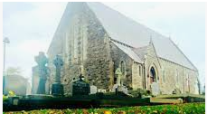  Irish for the month  I rith na Samhna cuimhnímis ar na mairbh  (I ree na sowna kivkneemish ar na marv)  During November let us remember the dead  Classroom Instructions  Maidin mhaith a pháistí :  Good morning children  Maidin mhaith a mhúinteoir : Good morning teacher  Trathnona maith a pháisti :  Good afternoon children  Trathnona maith a mhúinteoir : Good afternoon teacher  Gabh mo leithscéal : Excuse me  An bhfuil cead agam dul amach? Tá/Níl : Can I go outside?  An bhfuil cead agam dul go dti an leithreas? Tá/Níl : May I go to the toilet?  Cuirigi lámh in airde: Put your hands up  Maith thú: Well done  Le do thoil : Please  Go raibh maith agat : Thank you  Suigh sios : Sit down  Seas suas : Stand up  Bí ciúin : Be quiet  Éist le do thoil : Listen please  Oscail an leabhar : Open the book  Cuir ort do chóta : Put on your coats  Deanigi line : Line up  Siúil amach : Walk out  Tagigi isteach : Come in  Bualadh bos : Clap hands  Irish can be accessed from http://ccea.org.uk/curriculum/gaeloideachas/piasch and then click on Language and Literacy.  Grammar for the Month  I was like walking Incorrect X  I was walking Correct √  I was like saying Incorrect X  I was saying Correct √  Rule: If you wouldn’t write it don’t say it!
Dates for Term One / Two  Thursdays Ongoing Swimming for the P7 class  Wednesdays Once a month Adoration for P4-7  Thursdays Ongoing Library visits  Monday 4 December Children will sing at the Christmas Lights Switch in Garvagh 6.30-8.30pm  Thursday 7 December P4, 5, 6 & 7 Christmas Show  Monday 18 December P1, 2 & 3 Christmas Show  Thursday 21 December School closes at 12 noon  Thursday 4 January School reopens.  Friday 26 January P4 Assembly  Friday 1 March P3 Assembly  Saturday 23 March Confirmation – St Mary’s Ballerin at 11am  TOPICS  The children enjoy learning all about the world around them. In learning through their topics children are able to apply their learning and develop cross-curricular skills. |  | During/Afterschool Clubs  Mondays Ongoing Choir P5 – P7 from 3-3.45pm with Mrs Bradley & Mrs McGill  Wednesdays Ongoing Gaelic with Gavin  Thursdays 9 – 23 Nov Cookery Club with Miss Conway for P3 (Max 10)  Thursdays 30 – 14 Dec Second group Cookery Club for P3 (Max 10)  Thursdays 9 Nov – 14 Dec Handball for P6 pupils with Mrs Ball  Thursdays 9 Nov – 14 Dec Camogie with Mr McCann for P4 & P5 girls  School Dinners and Free School Meals  School dinners cost £2.60 per day, please send in an envelope. Please make cheques payable to the Education Authority.  The number of pupils who are on the free school meals’ register affects the school budget. If you are in any doubt as to whether you are entitled to free dinners please complete a Free School Meals’ form which is available via the EA’s website, https://www.eani.org.uk/financial-help/free-school-meals-uniform-grants, even if you do not wish your child to actually take dinner.  Child Protection and Safeguarding.  Children are encouraged to share any worries with their parents, and in school with any adult. The school will remind children regularly that Mrs Ball (Designated Teacher for Child Protection), Mrs McCloy and Mrs Heron (Deputy Designated Teachers) are always available to handle any concerns.  Collection of Children from EA Bus  It is important to note that, according to the EA Transport policy, our school bus driver cannot let children off the bus unless a responsible adult is there to collect them.  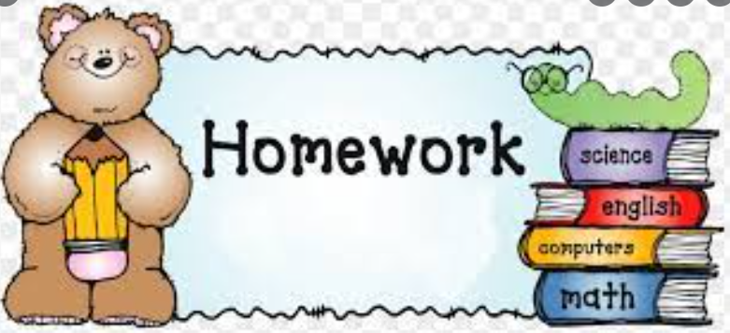  We understand that on occasion it is virtually impossible and impracticable for your child to complete their homework. When this is the case simply send the teacher a dojo stating that, ‘It is impractical for Sean to complete his homework tonight.’  No further explanation is necessary. It is optional if you the parent wants the child to complete the homework on a different night.  Allergies / Medical Needs  As you are aware a number of children within the school are allergic to nuts and or eggs. As an anaphylactic reaction to these foods can be potentially life threatening, we ask that all parents ensure that no nut products (e.g. Kinder eggs/ bars) or egg (such as egg sandwiches) be brought into the school.  Administering Medication  If your child has a medical condition and required medication, please ensure the medication is in date.  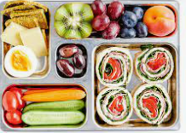  Boomerang Lunches  To encourage recycling and in order that parents can gauge what children have eaten for their lunch and break the school has a boomerang lunch policy. This means that all packaging or uneaten lunch will return home in the pupils’ lunchboxes.
Primary 1 – All About Me
Primary 2 – Wow Wee, Look at Me!
Primary 3 – Castles & Knights
Primary 4 – Mighty Me
Primary 5 – Where We Live
Primary 6 – Famine
Prmary 7 – Rainforest

Library Visits
Each class will have the opportunity to visit Garvagh library between now and Christmas. This is a great support and enhances the excellent provision for reading in the school.

Mathletics
Mathletics is an excellent fun maths learning programme. Pupils thrive on the competitive element of obtaining points by competing against other pupils online or by completing tasks independently. Pupils are given appropriately levelled activities which are in line with the Northern Ireland Curriculum. ‘Mathletics’ will be used both in school and at home.

The cost per pupil is £5 (approximately 10p for 52 weeks / 25p if only used for 20 weeks) with a maximum payable of £15 per family. Parents who subscribe will ensure their child has access to unlimited tutorials for 52 weeks.

We would urge all parents, regardless of the age or ability of your child to support this initiative as we believe that it is a relatively inexpensive way of significantly improving your child’s mathematical results.

New Mathletics Certificate System
Mathletics have recently updated their certificate system. There are now 8 certificate levels with 5 ranks within each certificate. This means that there are now 40 certificates in total that students can earn each academic year.
A certificate is earned by achieving 1000 points (or more) in a week. The Mathletics week starts from Monday morning and runs until midnight on Sunday evening.
The new certificate types are as follows:
-Bronze, Silver, Gold, Platinum,
-Emerald, Diamond, Epic and Legend
As a reward for their efforts and hard work, pupils will visit the shop when they achieve their 5th Platinum certificate and again when they achieve their 5th Legend certificate.
Certificates will now be reset each year, so that every year students have a chance of being able to achieve Legend status. We hope this will encourage pupils to engage with Mathletics regularly to ensure they are on track to earn the highest rewards possible.

